The plans below show the site of an airport now and how it will look after redevelopment next year.
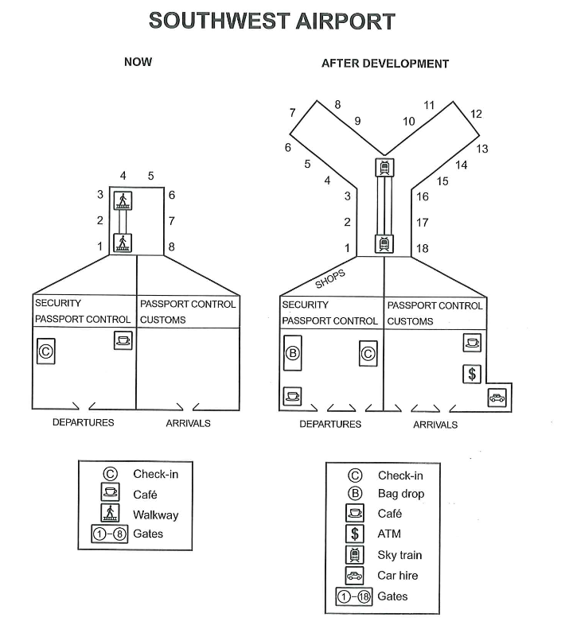
GPT Band 8
The given plans illustrate the current layout of an airport and the redevelopment proposed for the following year.
Overall, the airport is set to undergo a substantial modernization, with both the departures and arrivals areas being significantly expanded. The number of gates will more than double, while new facilities such as shops, cafés, and car hire services will be introduced to improve passenger convenience.
In the departures area, several notable changes are planned. At present, there are eight gates connected by a walkway. This will be increased to 18 gates arranged in a semicircular layout and linked by a modern sky train, replacing the older walkway system. The check-in desk, currently on the left, will be relocated to the right-hand side, with a new bag-drop facility installed in its original position. Furthermore, additional retail outlets will be introduced in the departure hall, and the café will be repositioned to the opposite corner, enhancing consumer services.
Turning to the arrivals area, which currently has no significant facilities, several key upgrades are planned. Immigration and customs will remain in their existing locations, but new shops, a café, and car-hire services will be added, offering passengers greater comfort and accessibility upon arrival.

